Spring Data JPA with Spring Boot, Hibernate
- spring-data-jpa-handson
Spring Data JPA - Quick Example
Solution:
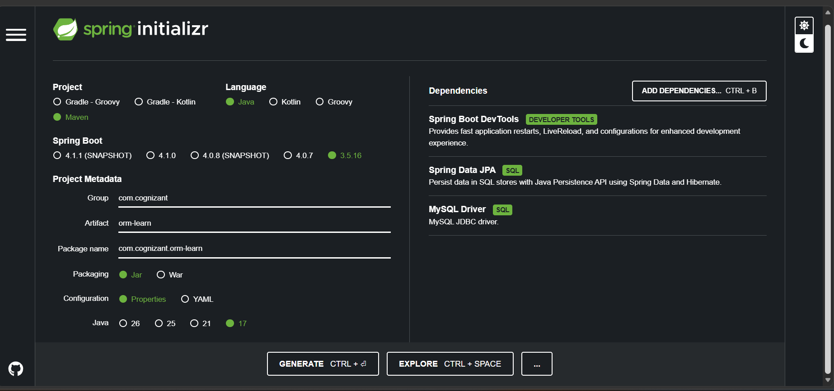
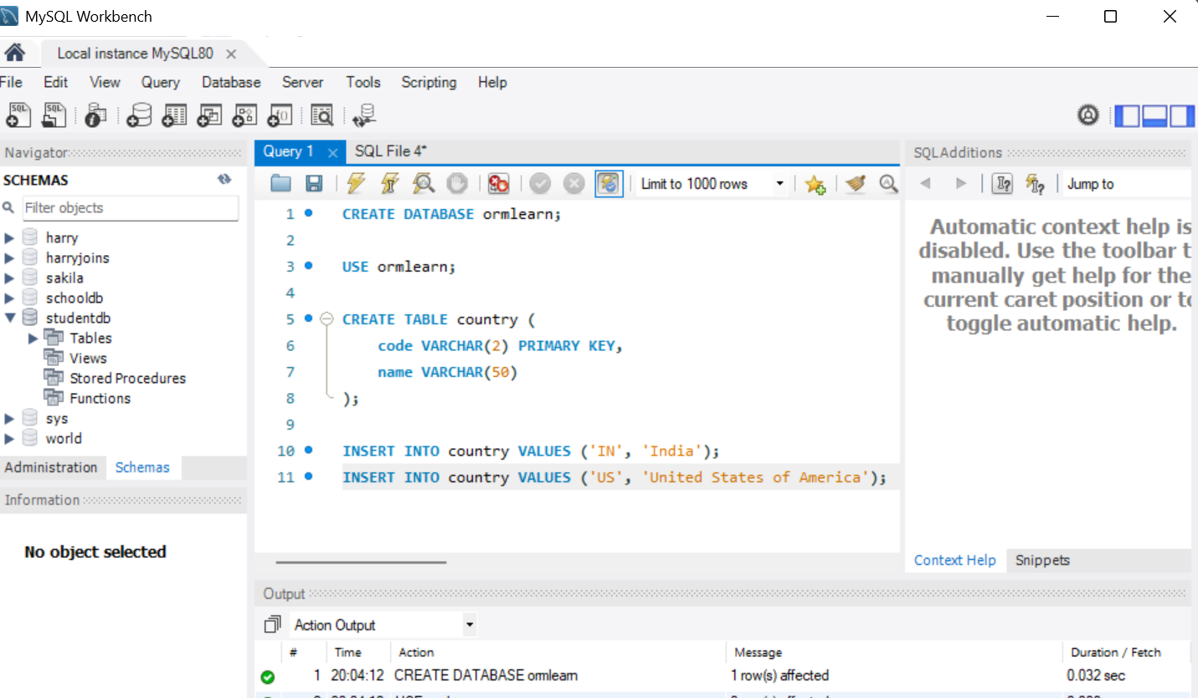
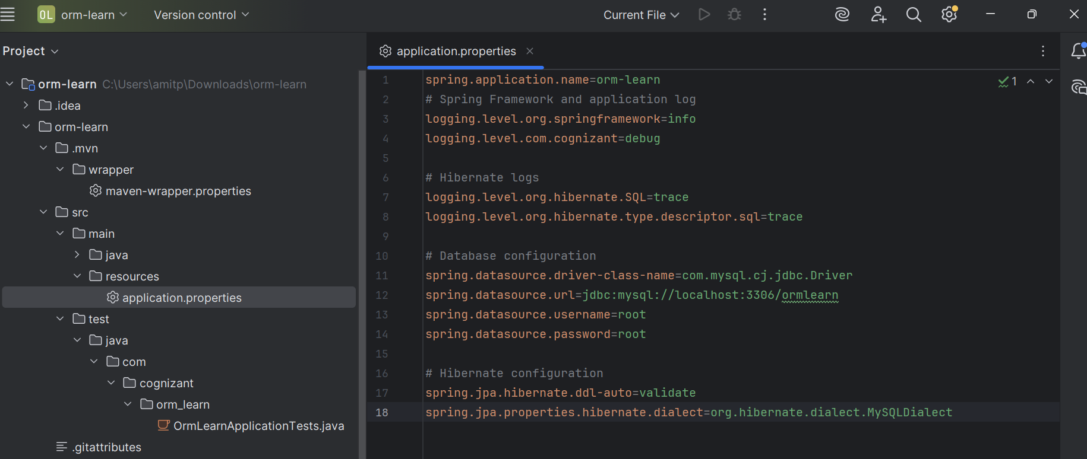
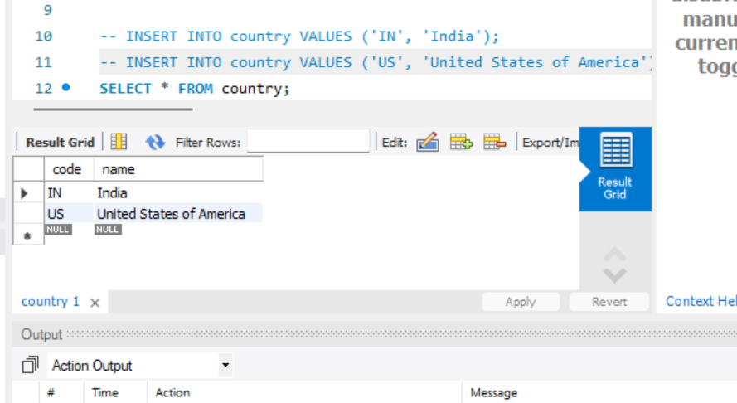
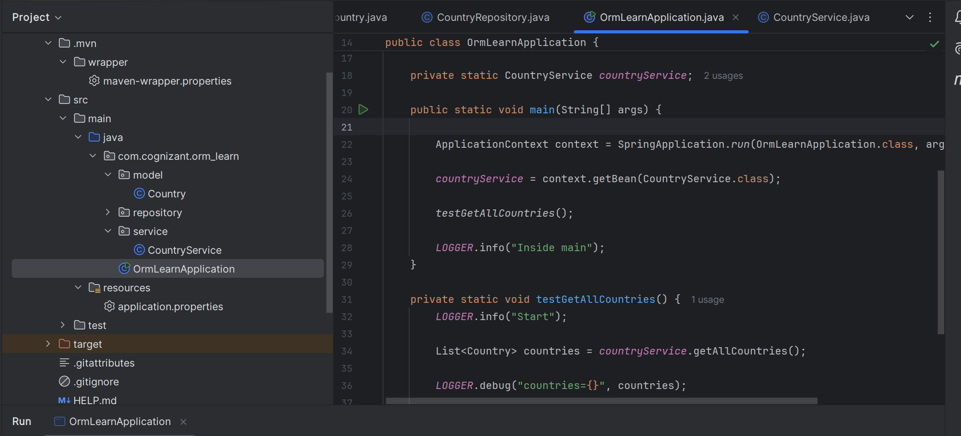
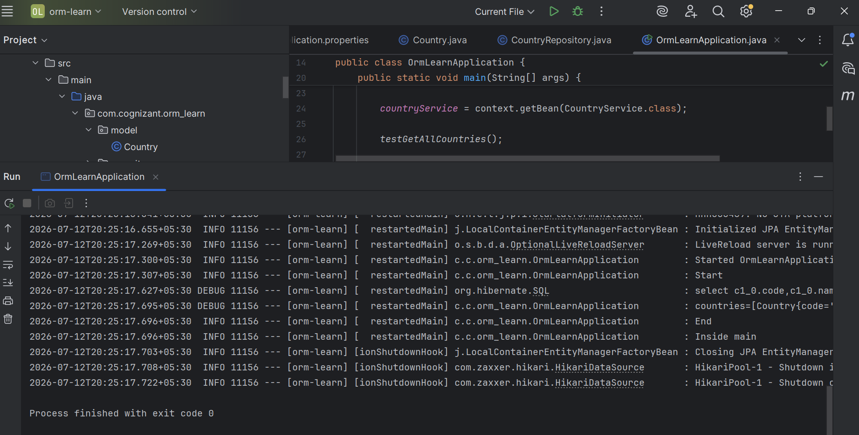

- Difference between JPA, Hibernate and Spring Data JPA
Solution:
Objective:
To understand the differences between JPA, Hibernate, and Spring Data JPA and compare how CRUD operations are performed.
Observation:
- JPA is a specification.
- Hibernate is an implementation of JPA.
- Spring Data JPA reduces boilerplate code and simplifies database operations using repositories.
Conclusion:
Spring Data JPA uses Hibernate internally and provides methods like save(), findAll(), and deleteById() without requiring manual session and transaction management.

